2. Microservices with API gateway

# **Creating Microservices for account and load**

**Microservice 1: Account**

**Project Creation (Spring Initializr):**

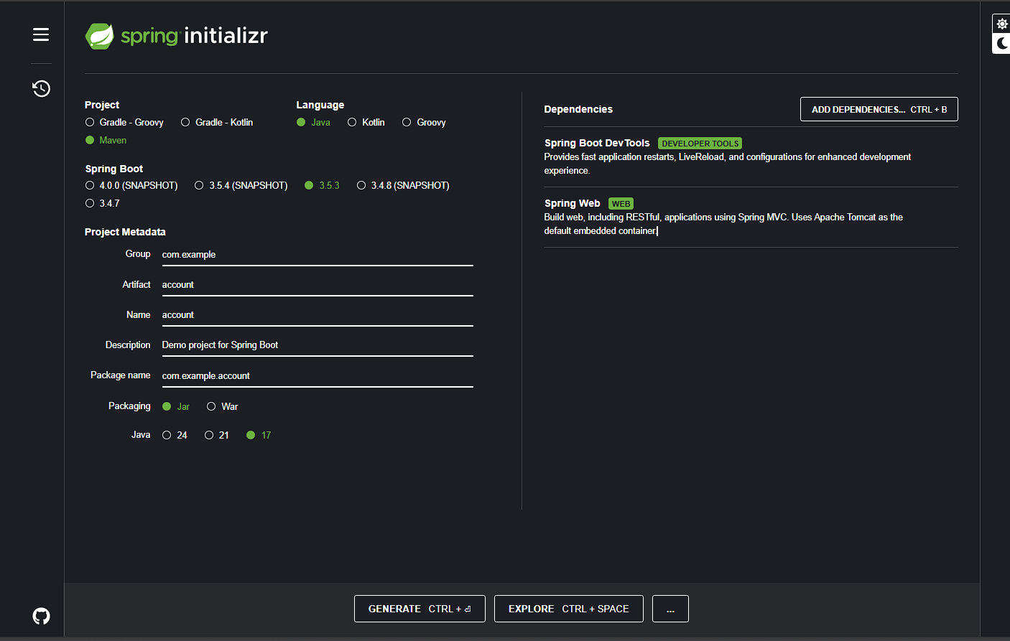

**AccountController.java :**

package com.example.account;

import org.springframework.web.bind.annotation.*;

@RestController

@RequestMapping("/accounts")

public class AccountController {

@GetMapping("/{number}")

public Account getAccount(@PathVariable String number) {

return new Account(number, "savings", 234343);

}

public static class Account {

private String number;

private String type;

private double balance;

public Account(String number, String type, double balance) {

this.number = number;

this.type = type;

this.balance = balance;

}

// Getters and setters

public String getNumber() { return number; }

public String getType() { return type; }

public double getBalance() { return balance; }

public void setNumber(String number) { this.number = number; }

public void setType(String type) { this.type = type; }

public void setBalance(double balance) { this.balance = balance; }

}

}

}

**AccountApplication.java :**

package com.example.account;

import org.springframework.boot.SpringApplication;

import org.springframework.boot.autoconfigure.SpringBootApplication;

@SpringBootApplication

public class AccountApplication {

public static void main(String[] args) {

SpringApplication.run(AccountApplication.class, args);

}

}

**OUTPUT :**

**IN TERMINAL :**

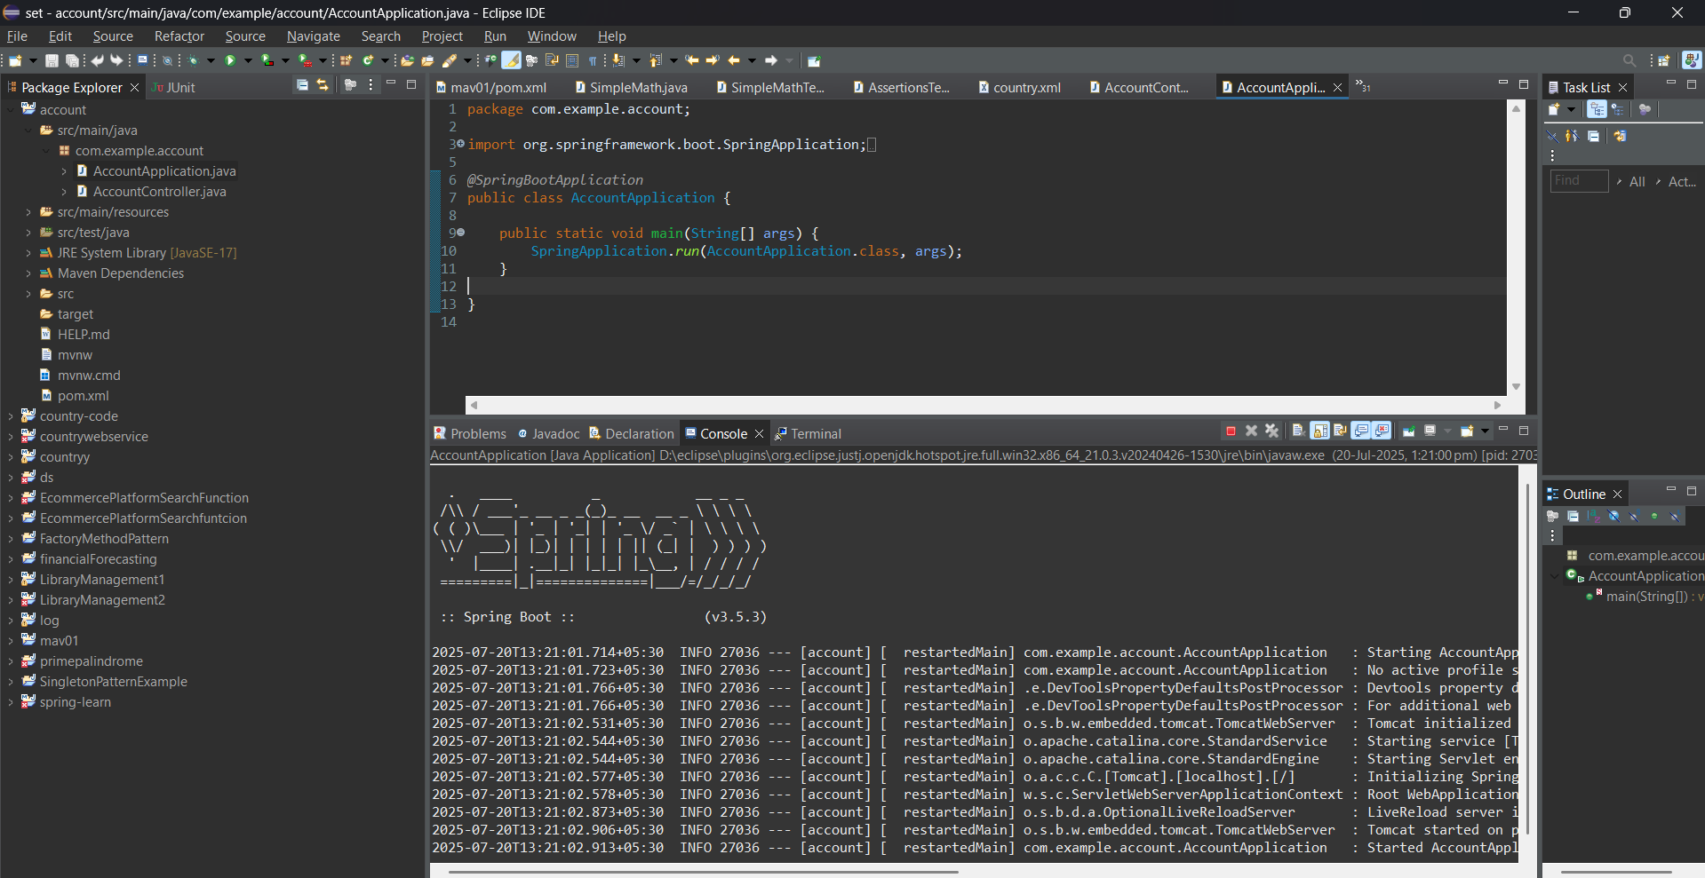

**IN CHROME BROWSER :**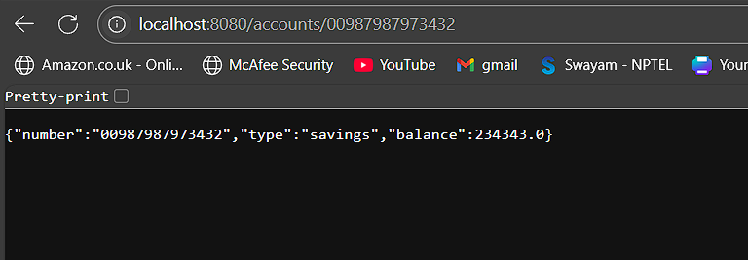

**Microservice 2: Loan**

**Project Creation (Spring Initializr):**

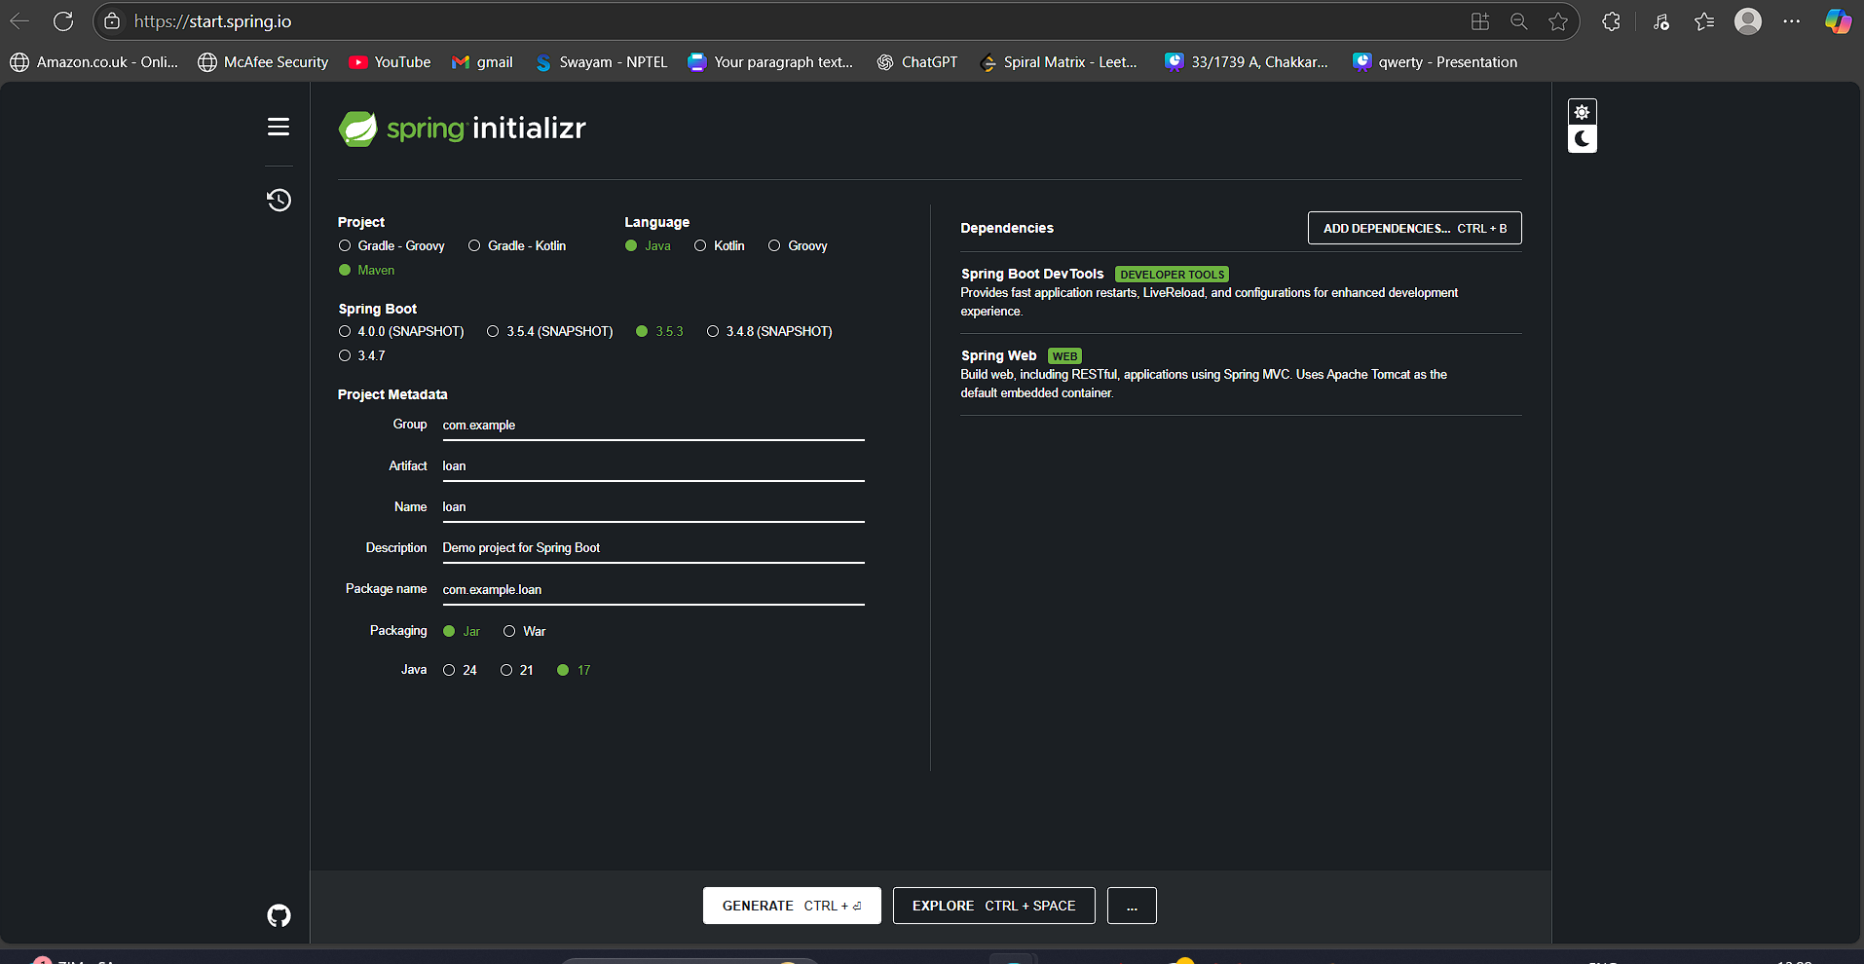

**LoanController.java :**

package com.example.loan;

import org.springframework.web.bind.annotation.*;

@RestController

@RequestMapping("/loans")

public class LoanController {

@GetMapping("/{number}")

public Loan getLoan(@PathVariable String number) {

return new Loan(number, "car", 400000, 3258, 18);

}

public static class Loan {

private String number;

private String type;

private double loan;

private double emi;

private int tenure;

public Loan(String number, String type, double loan, double emi, int tenure) {

this.number = number;

this.type = type;

this.loan = loan;

this.emi = emi;

this.tenure = tenure;

}

// Getters and setters

public String getNumber() { return number; }

public String getType() { return type; }

public double getLoan() { return loan; }

public double getEmi() { return emi; }

public int getTenure() { return tenure; }

public void setNumber(String number) { this.number = number; }

public void setType(String type) { this.type = type; }

public void setLoan(double loan) { this.loan = loan; }

public void setEmi(double emi) { this.emi = emi; }

public void setTenure(int tenure) { this.tenure = tenure; }

}

}

**LoanApplication.java:**

package com.example.loan;

import org.springframework.boot.SpringApplication;

import org.springframework.boot.autoconfigure.SpringBootApplication;

@SpringBootApplication

public class LoanApplication {

public static void main(String[] args) {

SpringApplication.run(LoanApplication.class, args);

}

}

**OUTPUT :**

**IN TERMINAL :**

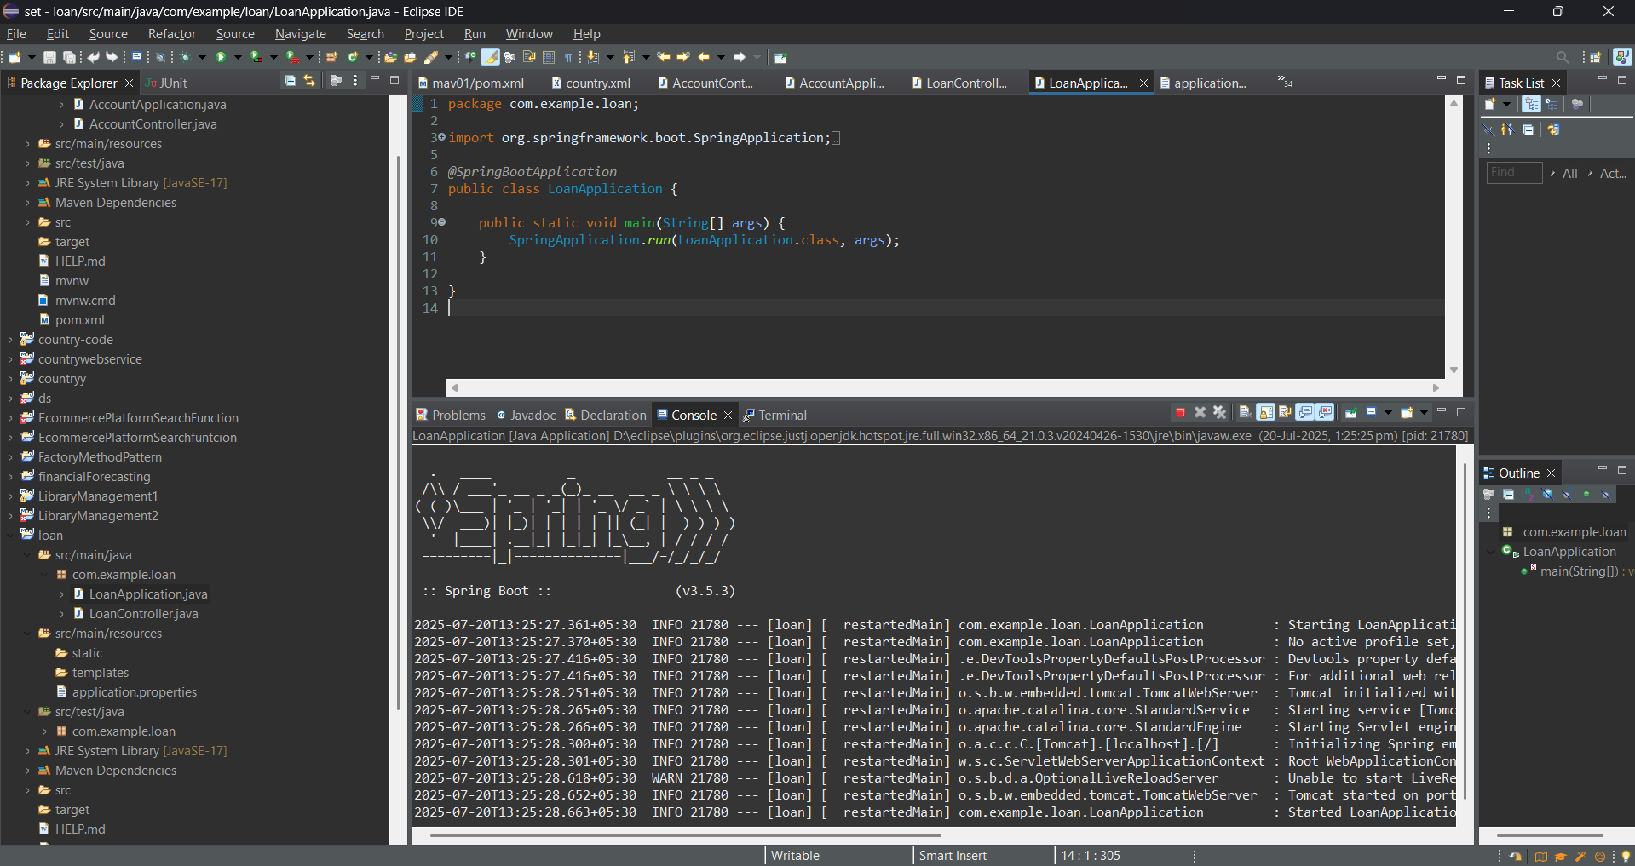

**IN CHROME BROWSER :**

